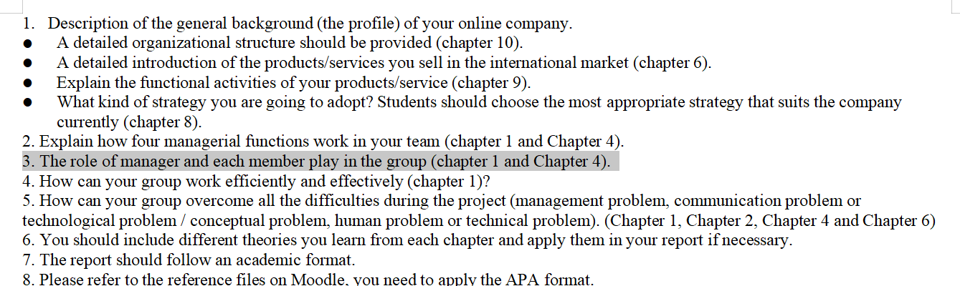

**The description of the company management**

With the increasingly fierce market competition ,enterprises are faced with increasingly complex and changeable external environment. Therefore , it is so urgent to improve the efficiency and quality of strategic decision-making to cope with the external environment(**1**).In response to the rise of global organizations ,our company will set up branches in different regions.And the management structure of each branch is the same.The goal of our home decoration company is to expand the global market while maintaining an efficient and highly consistent management structure.

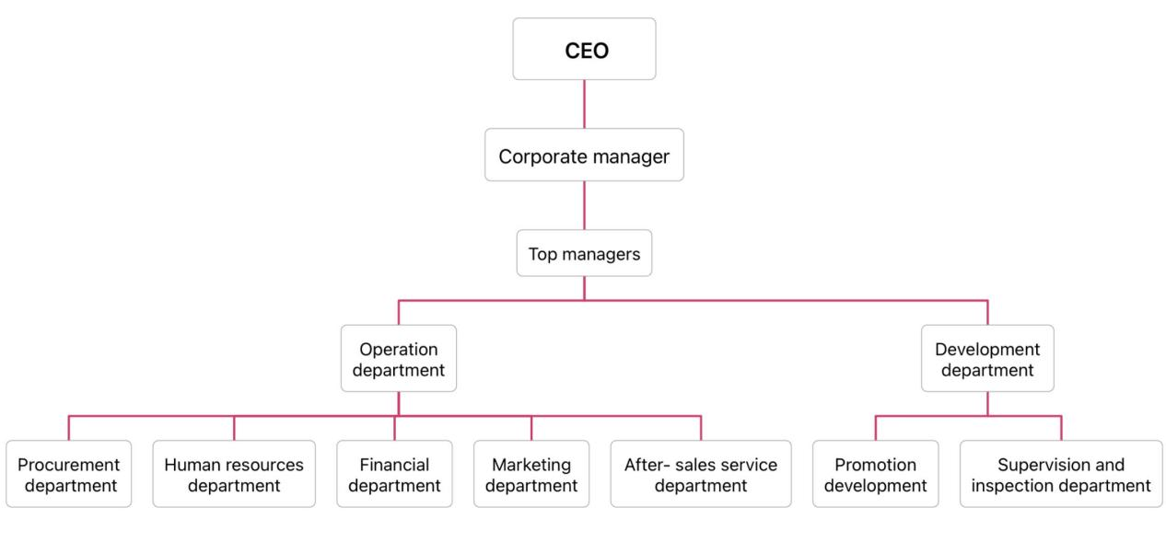

For every company, there are high value added and low value added jobs . According to the environment of the work to choose different professionals to engage in the highest division of labor efficiency**(2) .**As for the composition of our company's management, we have the positions of CEO and corporate manager at the corporate level. For business or division level, we set up subsidiary in each region. And each subsidiary has a top manager to manage the functional level departments, including the operation department and the development department.The development department includes promotion department and supervision and inspection department. The operation department has five branches, procurement department, human resources department, financial department, marketing department and after-sales service department .Each department directly cooperates with each other and fully serves the company's chain management system through mutual cooperation. By maximizing and utilizing the company's operational resource advantages,our management mode ensures the standardized and healthy development of the company's chain management.

**The role of CEO and manager**

According to the management forum(**3**) ,the organization depends more and more on excellent leadership .Because of the outstanding leadership ,they can lead the organization through the difficulties to create success . The CEO in our company is responsible for institutional strategy who identified the company's “integrated service” from procurement to decoration to after-sales service.At the same time, CEO also defined prime policy to target customers with high consumption. In addition ,CEO is in charge of planning the strategy of opening branches worldwide and applying the same management.

Then is corporate managers, who take the responsibility for the performance of all departments, decide how different departments should interact and monitor how well the manager in subsidiary corporation use resources to achieve goals.

**The operation department**

Procurement department

As a home decoration company ,we provide services including furniture purchase and home decoration.Procurement department is indispensable to our company. We purchase different smart furniture in the global market, which makes our managers need to constantly change suppliers to purchase. To build our excellent reputation and brand value ,our company's requirement to the procurement department is to strictly control the quality and style of furniture.Each customer has different requirements for the style and performance of smart furniture,and the duty for the procurement department is trying to meet the needs of customers to the greatest extent.

Human resources department

Our human resources department includes six aspects: human resources planning, recruitment and allocation, training and development, performance management, compensation and welfare management and labor relations management.It is worth mentioning that we have a high standard of our recruitment and training.As a human resources department, we need to strictly check the selection of talents.We tend to select young people from five main standard: understanding and communication skills, spatial planning skills, aesthetic standards, color perception, and cost perception.After a long period of internship and training with experienced engineers, they are able to work independently and give full play to their talents.Rigorous screening and training always earn the trust of customers.In addition, the welfare system and salary are much higher than the peers. Scientific performance management is also the key to maintain the stability of our team. That's why so many young people want to be a part of our company.

Financial department



The finance department controls the financial lifeblood of our company,which is also closely related to other departments. For example, the budget and reimbursement of the purchasing department need to be applied to the finance department. Business investment and advertising promotion are also closely related to the health of the finance department. The financial department needs to participate in the enterprise operation and decision and allocate the operation fund reasonably.

Marketing department

For the marketing department, we need to do a good job of marketing management personnel planning layout and marketing plan, in order to effectively use the scientific marketing strategy management ideas, to provide support, help and service for marketing management decision-making level. To create products and customers trust cooperative brand, to wholeheartedly for the product sales channels to establish brand awareness and popular awareness, to stimulate consumer demand and professional brand market research approach, to wholeheartedly for customers to create the first choice of high-end products, in order to achieve product sales value and product quality assurance.

After-sales service department

After-sales service is the last step of our company's service, our company promises to provide high-quality service to customers from the beginning to the end. The after-sales service department will track the customer's after-sales information after purchasing .Visiting the customer regularly and record the possible shortcomings in detail. We have a complete system of after-sales service. For customers ,they can call the company hotline 24 hours if there is a situation that can’t be resolved , we will send people to the customers' houses at once. In addition, if our staff bring discomfort to customers or the quality is not up to standard, our customer has the right to apply for compensation.

**The development department**

Promotion department

As a company with branches all over the world, company promotion is our necessary work. Different regions for home decoration requirements are not similar.Therefore, the promotion department not only needs to pay close attention to the development of the furniture decoration industry, but also need to has a clear understanding to the local market. In order to grasp the psychology and behavior of consumers,promotion department will conduct market research .According to the information about industry and local market, promotion department will carry out the planning and implementation of marketing planning and brand promotion, which relates to the decision-making basis and information basis for the company's market activities under the guidance of marketing objectives. All marketing and promoting activities are mainly to maintain the company's reputation.

Supervision and inspection department

The inspection and supervision department of the company is a big guarantee for both of enterprises and customers. The inspection and supervision department will accurately and carefully check whether the purchased furniture meets the quality requirements and customer needs. They will check on the talent selection and training results of Human resources Department. Supervision and inspection department will also check the performance management from human resources department , money flow of the finance department and the feedback of after-sales service for follow-up inspection. Supervising the inspection department is our bottom line as well as our responsibility to our customers for the reason that we promise to provide the best service.

**Reference:**

**(1)马长龙 葛玉慧 赵恒. (2022). 高管团队多元化与组织绩效的关系. 中国人力资源开发, 200093, 39–40.**

**(2 )朱孝忠. (2012). 公司分工效率及岗位设置. 3(138), 50–51.**

**(3)马长龙 葛玉慧 赵恒. (2022). 高管团队多元化与组织绩效的关系. 中国人力资源开发, 200093, 39–40.**